1 Before powering on the Pi, connect the sense HAT to the Pi. Start the Pi and once booted, open Python3*.*

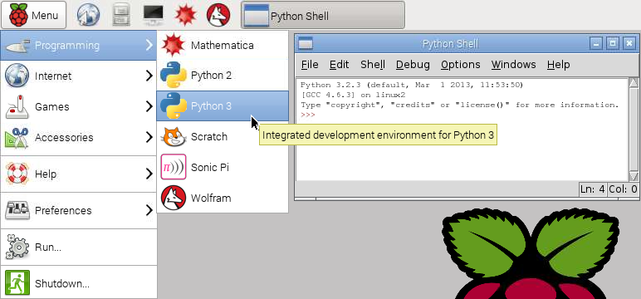

2 From the python shell open a new window (File > New Window). Start by saving this new file to the home directory as helloworld.py. Then enter the following lines of code

|  |
| --- |
| from sense_hat import SenseHat  sense = SenseHat()  sense.show_message(“Hello World”) |

3 Double check you have typed everything exactly as shown then save the file with these changes

4 Back in the python shell window select Run > Run Module. The Hello World message should scroll across the LED display in white letters. Yay!

5 Try changing the program to display your name instead. Good luck!